# **Take and Make: Reuleaux Car**

Lauren Siegel

January 14, 2022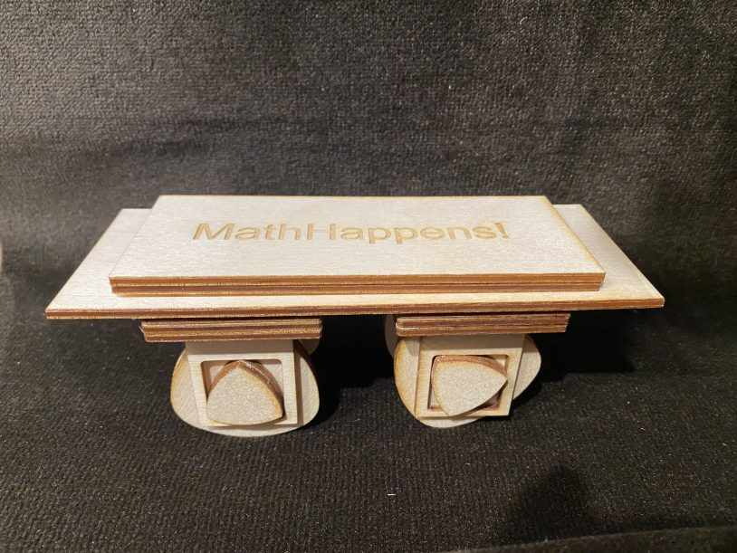

The file has a laser etch on the big wheel to guide the placement of the smaller piece. Glue two small pieces to one side and two large ones on the other side. The wheel holders work by sliding so you can install the small section in the square, and then slide the other side into place.

This project was inspired by a post on twitter: <https://twitter.com/74WTungsteno/status/1480661066053189633?s=20> the video and graphics by Mathematical Etudes make the math and mechanics of this really clear. <https://en.etudes.ru/etudes/reuleaux-triangle/>

Pro tip – Not shown is paraffin wax which really helps everything move. Wax the wheel sides before you put them in. If you treat the wheels like a fidget and just work them a bit the motion gets smoother. Also rolls best on a mouse pad or other tacky surface. Have fun!

There is an amazing repository of actual made Reuleaux devices at Cornell University — [check it out to get inspired!.](https://digital.library.cornell.edu/?f%5Bcollection_tesim%5D%5B%5D=Reuleaux+Kinematic+Mechanisms+Collection&per_page=100&view=list)

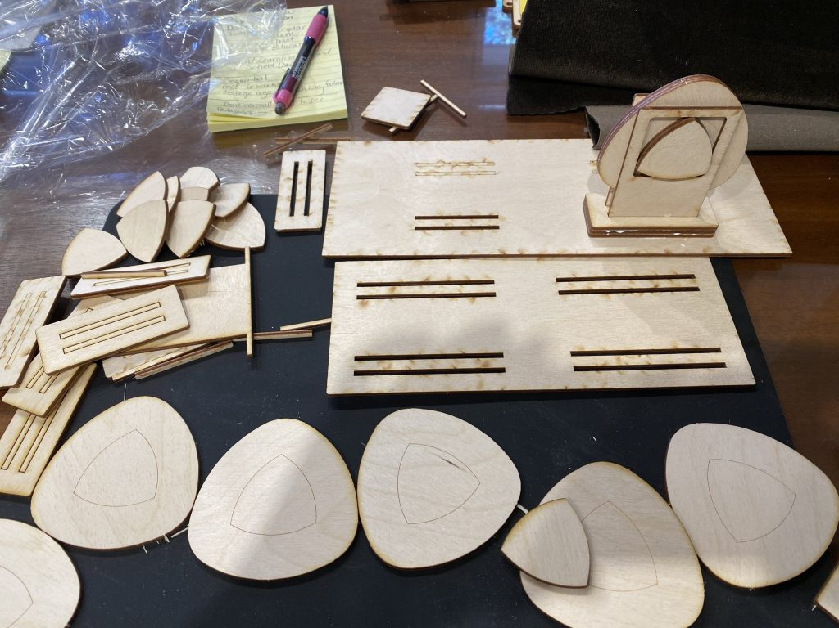

PIECES

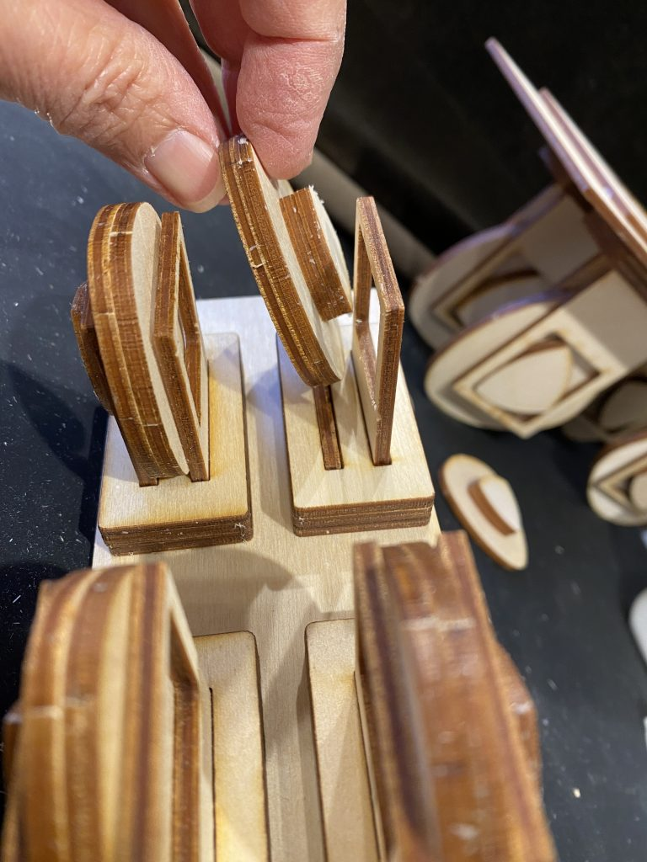

ONE SIDED WHEEL, SLIDE THE HOLDER DOWN, INSTALL THE WHEEL AND SLID IT INTO PLACE

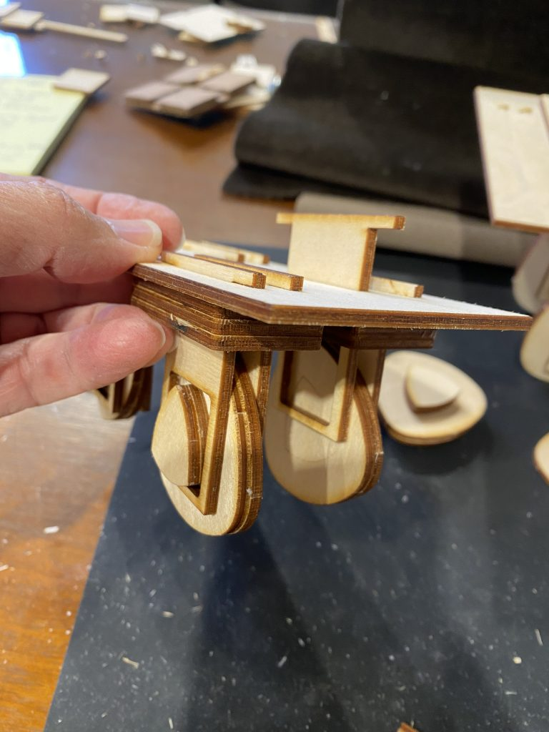

SLIDE WHEEL HOLDER INTO PLACE. SOME BRACES KEEP EVERYTHING STRAIGHT.

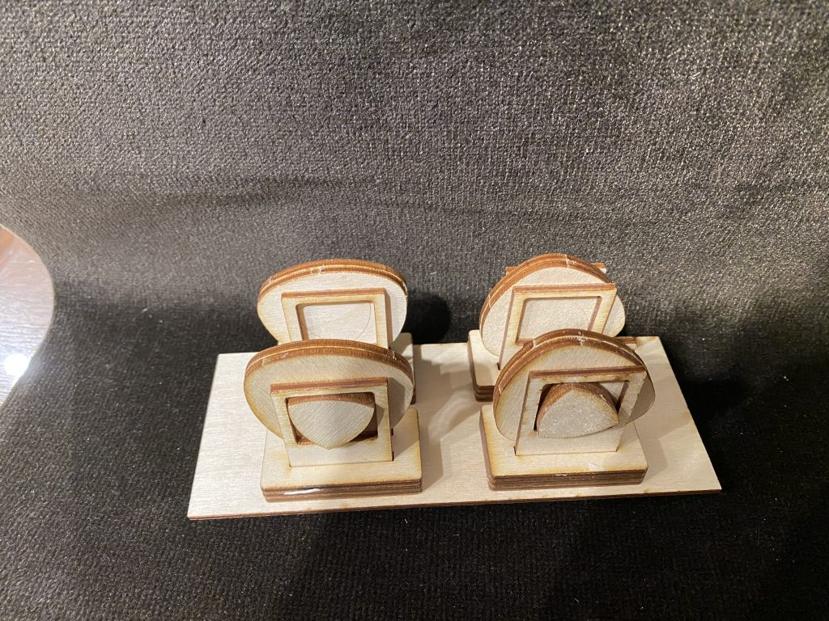

GLUEING THE WHEEL COMPONENTS DOWN

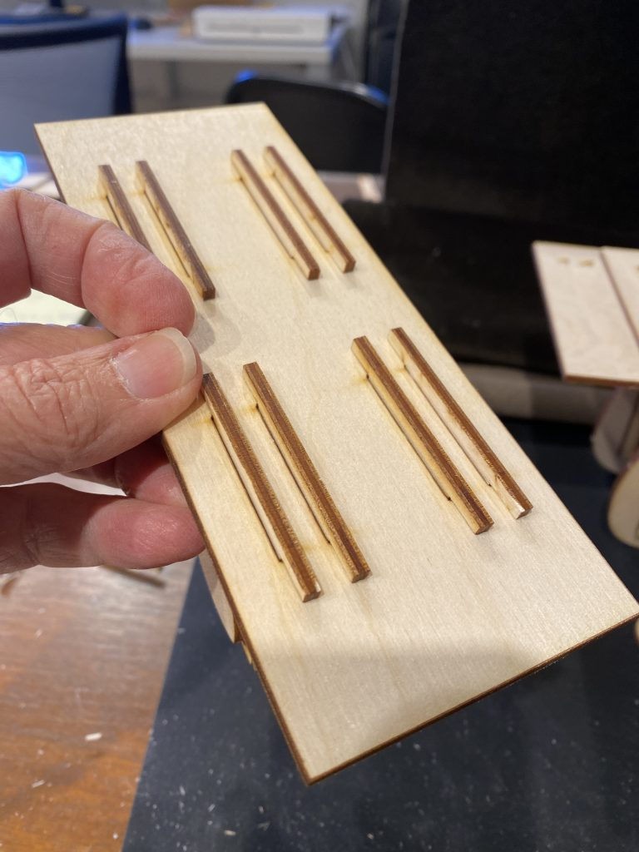

ON TOP, THE WHEEL HOLDER HAS A LONGER TOP.

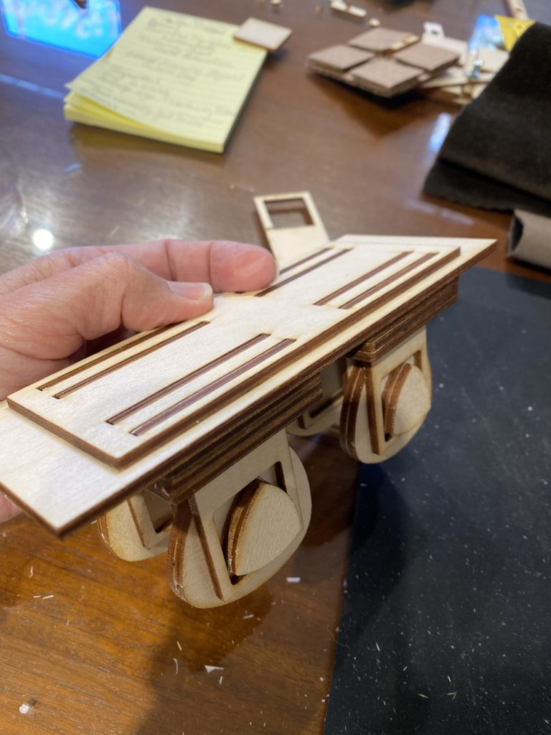

SECURE THE LONGER TOP IN PLACE WITH A FLAT PIECE.

And then at the end glue one more piece on top.

Here are the parts:

